Beneteau 211 Keel Servicing
alansm04@yahoo.co.uk

Note: This is an account of my experience and not a ‘good practice guide’. Seek professional assistance if you are unsure about your ability!

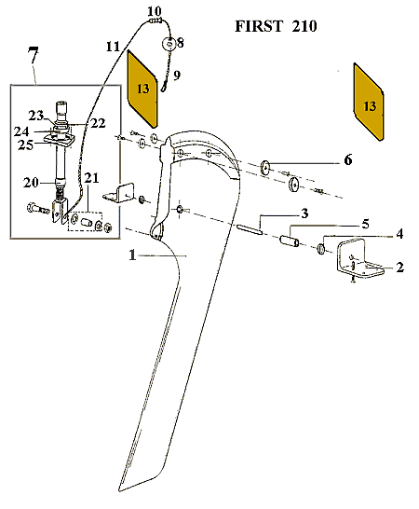
My First 211 is 12 years old and used in salt water. The keel has been progressively noisy, making clanking sounds in rough waves. I noticed that it was leaning to one side by several degrees when placed on the trailer this year so I decided to replace the keel pivot, nylon bushes and angle brackets.
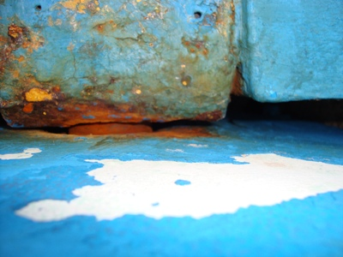

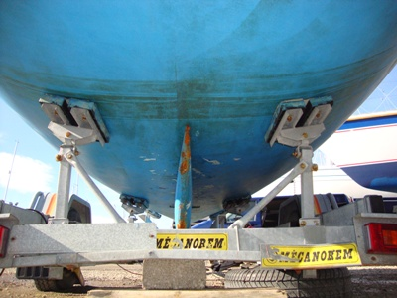
I decided to do the work from my trailer by raising the boat 50mm on Styrofoam pads which gives just enough clearance. The hardest part of this job is breaking the seal between the brackets and hull. It eventually released by levering the keel up and down with a crowbar and using the full weight of the keel.

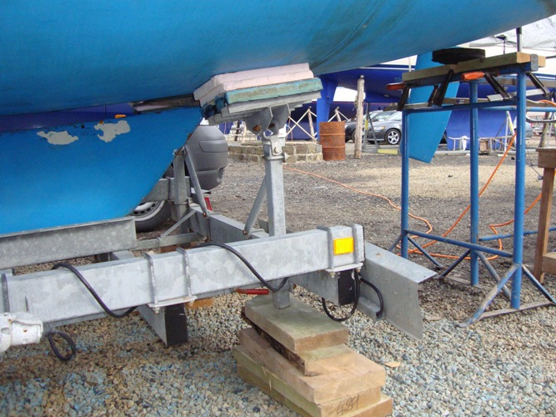 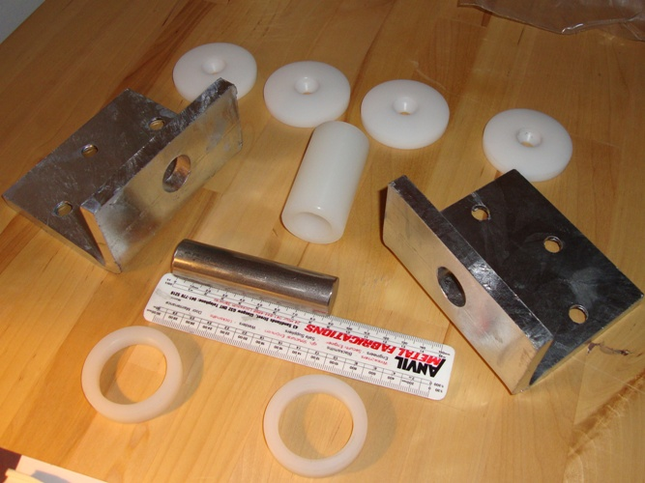
The job was reasonably straight forward but the new bracket holes didn't align correctly which was a bit of a pest to say the least! CHECK THE HOLE ALIGNMENT BEFORE APPLYING ANY MASTIC! The brackets were ordered from Beneteau and £50 a piece. They are 10mm galvanised mild steel (not Stainless). If I did this again I'd have the new brackets fabricated in stainless.
When I removed the old brackets I was alarmed to see how corroded and oval the holes had become. Another season could have resulted in the keel falling out!
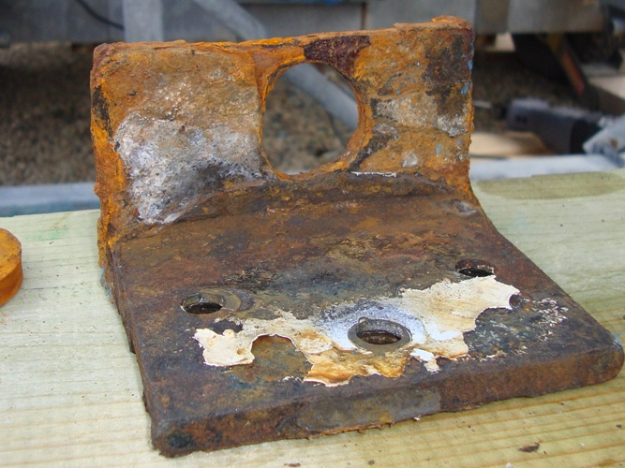 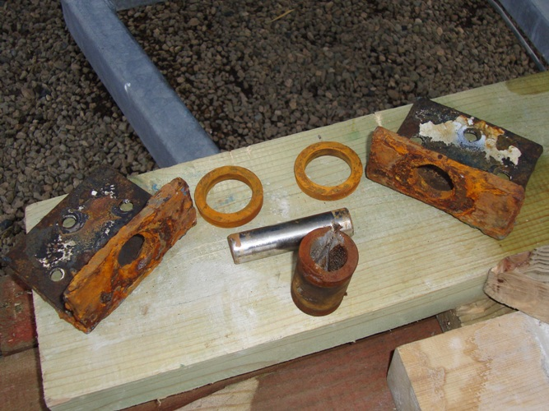
The nylon parts and the original stainless steel pivot pin were all in perfect condition which makes me think that all the pivoting has been between the stainless steel pin and the mild steel brackets. I had to cut the nylon bearing through the keel as it wouldn't budge. The pivot hole through the keel was sound with no rust. I also decided to fit a zinc anode to help protect against future rust.
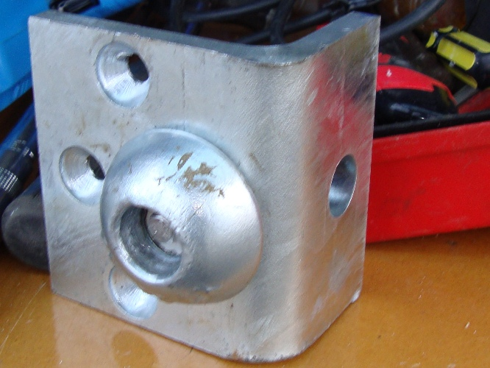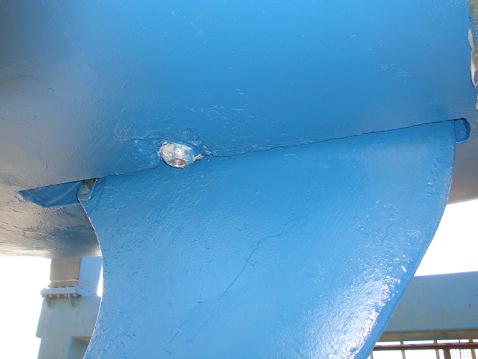
I painted the pivot holes on the angle brackets before inserting the new pin and greased the main nylon bearing to ensure that the pivoting would be in the correct place in future. I used plenty `Sikaflex marine sealant 291' to ensure a good seal around the bolts.
This job although daunting is reasonable straight forward if planned well.
I also had to repair the keel lifting mechanism as the fork was damaged and the bolt badly corroded. This is an M12 bolt with Nyloc nut (17mm spanner) This job can’t be done on the trailer but is easily accessible when the boat was lifted for launching. My local blacksmith fabricated and welded on a new stronger SS fork for £30.

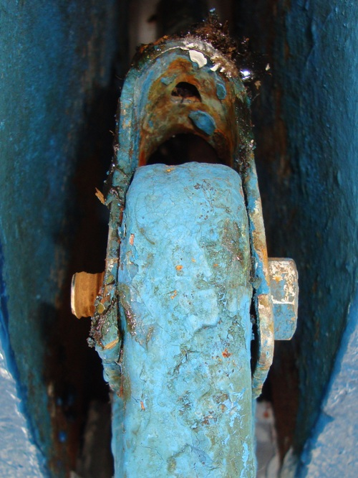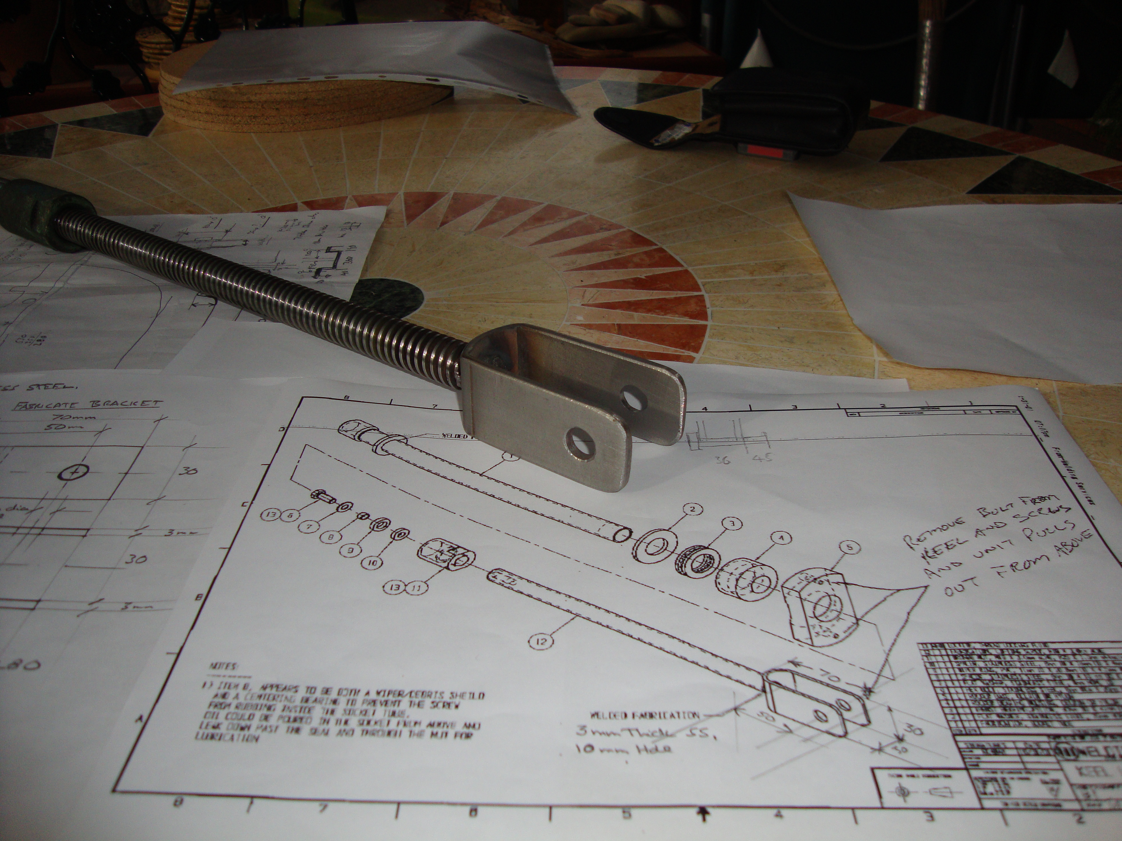
I had my first sail of the season yesterday and the boat has a much stiffer feel - with no clanking noise. (No leaks around bolts following first sail - phew!)
November 2003 Update: Had a really good season with plenty of exciting sailing. Still no noise from keel & no water ingress. A job worth doing.
Alan

